Linear Regression

# Formal Definition

Linear regression is a statistical method for modeling the relationship between a dependent variable and one or more independent variables. The model assumes that the relationship between the variables can be represented as a linear equation, where changes in the independent variables proportionally affect the dependent variable. The goal is to find the best-fitting line through the data points, minimizing the sum of squared differences between the observed values and the values predicted by the line.



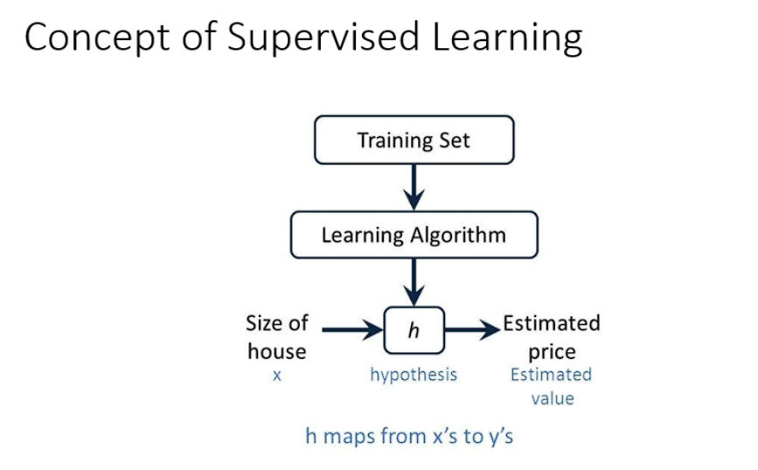

# Layman Explanation

Imagine you're at a farmer's market, and you notice that as the weight of apples increases, the price also goes up. If you wanted to predict the price of apples based on their weight, you could use linear regression. Essentially, you draw a straight line through the points representing different weights and prices. The idea is that this line helps you understand how much the price changes as the weight changes, so you can predict the price of apples in the future based on their weight.

# Examples of Linear Regression

## 1. Predicting House Prices

A common example of linear regression is predicting house prices. Suppose you have data on various houses, including their square footage and selling price. You can use linear regression to find a relationship between square footage (independent variable) and price (dependent variable). The resulting equation would help you estimate the price of a house based on its size.

## 2. Predicting Sales Based on Advertising Spend

Consider a company trying to predict future sales based on its advertising spend. By plotting past data showing the relationship between money spent on advertising and sales, you can use linear regression to find a line that best fits the data. This line would then help the company estimate future sales based on different levels of advertising spending.